Sentiment Analysis Workshop Installation – Customer Feedback Classification

YouTube videos are available for each step below.

## Install Steps

1. Install Conda.

Option 1.) Miniconda (lightweight option): <https://www.anaconda.com/download> Option 2.) Anaconda (includes more tools): <https://www.anaconda.com/download> Option 3.) Alternatively, you can install Python directly, but this won’t have the dependencies loaded.

[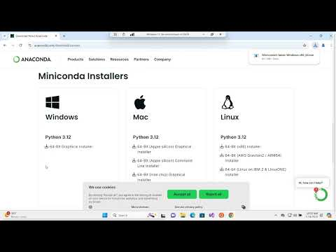](https://www.youtube.com/embed/wwKAFw2Dwz0?feature=oembed)

<https://www.youtube.com/watch?v=wwKAFw2Dwz0>

1. Install Cursor https://www.cursor.com/

Note: you will need to create a free account

[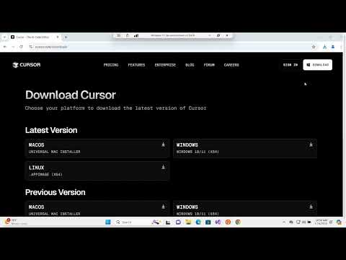](https://www.youtube.com/embed/L_A2P1KJYpw?feature=oembed)

<https://www.youtube.com/watch?v=L_A2P1KJYpw>

1. Download the github files + unzip + set up conda environment.

Github link: <https://bit.ly/3PIK4RU>

1. Download zip
2. Extract zip
3. Open **Anaconda Prompt**
4. In a conda prompt type (update to the directory with the Github files):

cd <*directory with files*>

conda env create -f environment.yml

conda activate workshop_env

[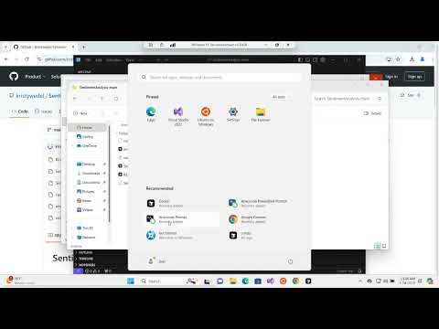](https://www.youtube.com/embed/Fv_tDvJuJpk?feature=oembed)<https://www.youtube.com/watch?v=Fv_tDvJuJpk>

1. Set up cursor with conda by testing a prompt.
   1. Open Cursor
   2. Navigate to the folder with the csv file. Note: this may be a subfolder depending on how the zip was extracted.

* 1. Log In.
  2. open the chat with Ctrl + L.

Prompt:

Create a python jupyter notebook to load customer_feedback.csv

* 1. Click Select Kernel
  2. Install python and jupyter extensions.
  3. Select workshop_env.



* 1. Click the play button.

* 1. Set up the Python interpreter: <https://tinyurl.com/4unvyzab>

Open the Command Palette (Ctrl+Shift+P), type "Python: Select Interpreter", and choose the appropriate Python version.

[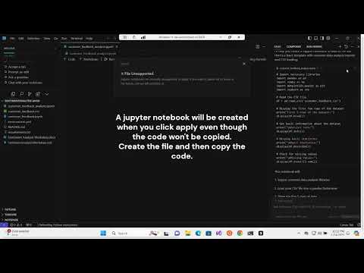](https://www.youtube.com/embed/kSbIeTXuuiY?feature=oembed)

<https://www.youtube.com/watch?v=kSbIeTXuuiY>